**LAB NO. 06**

**USE WIRESHARK TO VIEW NETWORK TRAFFIC TOPOLOGY**



**DATA COMMUNICATION AND COMPUTER NETWORKS LAB**

Submitted by:

Name : **Naveed Ahmad**

Reg no**. : 22PWCSE2165**

ClassSection **: B**

24 April 2025

**Submitted to:** **Dr. Yasir Saleem Afridi**

**Department of Computer Systems Engineering**

**University of Engineering and Technology, Peshawar**

**LAB 6 - USE WIRESHARK TO VIEW NETWORK TRAFFIC TOPOLOGY**

**Objectives:**

* Part 1: Capture and Analyze Local ICMP Data in Wireshark
* Part 2: Capture and Analyze Remote ICMP Data in Wireshark

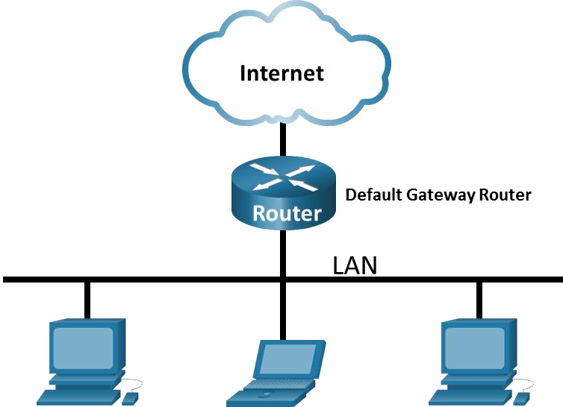

**Background / Scenario:**

Wireshark is a software protocol analyzer, or "packet sniffer" application, used for network troubleshooting, analysis, software and protocol development, and education. As data streams travel back and forth over the network, the sniffer "captures" each protocol data unit (PDU) and can decode and analyze its content according to the appropriate RFC or other specifications.

Wireshark is a useful tool for anyone working with networks and can be used with most labs for data analysis and troubleshooting. In this lab, you will use Wireshark to capture ICMP data packet IP addresses and MAC addresses.

**Required Resources**

* 1 PC (Windows with internet access)
* Additional PCs on a local-area network (LAN) will be used to reply to ping requests.

**Instructions**

**Part: 1 Capture and Analyze Local ICMP Data in Wireshark**

In Part 1 of this lab, you will ping another PC on the LAN and capture ICMP requests and replies in Wireshark. You will also look inside the frames captured for specific information. This analysis should help to clarify how packet headers are used to transport data to their destination.

**Step: 1 Retrieve your PC interface addresses.**

For this lab, you will need to retrieve your PC IP address and its network interface card (NIC) physical address, also called the MAC address.

Open a Windows command prompt.

1. In a command prompt window, enter ipconfig /all, to the IP address of your PC interface, its description, and its MAC (physical) address.

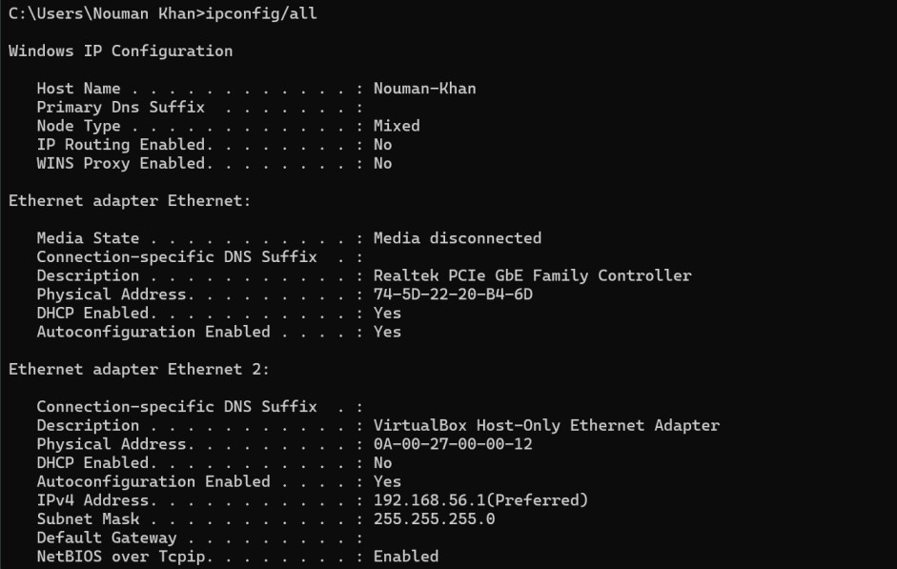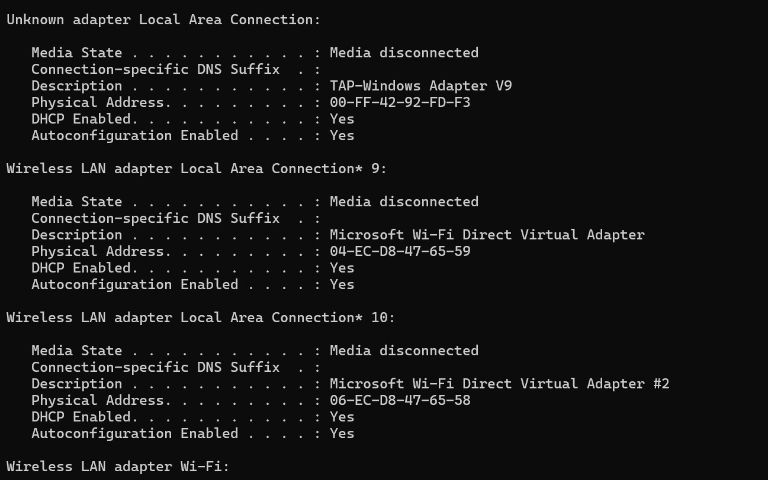

1. Ask a team member or team members for their PC IP address and provide your PC IP address to them. Do not provide them with your MAC address at this time.

Close a Windows Command Prompt.

**Step: 2 Start Wireshark and begin capturing data.**

1. Navigate to Wireshark. Double-click the desired interface to start the packet capture. Make sure the desired interface has traffic.
2. Information will start scrolling down the top section in Wireshark. The data lines will appear in different colors based on protocol.

This information can scroll by very quickly depending on what communication is taking place between your PC and the LAN. We can apply a filter to make it easier to view and work with the data that is being captured by Wireshark.

For this lab, we are only interested in displaying ICMP (ping) PDUs. Type icmp in the Filter box at the top of Wireshark and press Enter, or click the Apply button (arrow sign) to view only ICMP (ping) PDUs.

1. This filter causes all data in the top window to disappear, but you are still capturing the traffic on the interface. Navigate to a command prompt window and ping the IP address that you received from your team member.

Notice that you start seeing data appear in the top window of Wireshark again.

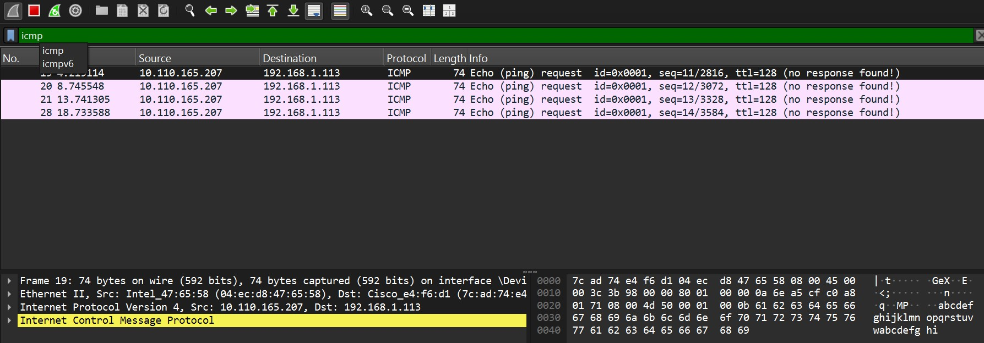

1. Stop capturing data by clicking the Stop Capture icon.

**Step 3: Examine the captured data:**

In Step 3, examine the data that was generated by the ping requests of your team member PC. Wireshark data is displayed in three sections: 1) The top section displays the list of PDU frames captured with a summary of the IP packet information listed; 2) the middle section lists PDU information for the frame selected in the top part of the screen and separates a captured PDU frame by its protocol layers; and 3) the bottom section displays the raw data of each layer. The raw data is displayed in both hexadecimal and decimal form.

1. Click the first ICMP request PDU frames in the top section of Wireshark. Notice that the Source column has your PC IP address, and the Destination column contains the IP address of the teammate PC that you pinged.
2. With this PDU frame still selected in the top section, navigate to the middle section. Click the plus sign to the left of the Ethernet II row to view the destination and source MAC addresses.

**Questions:**

Does the source MAC address match your PC interface?

Yes

Does the destination MAC address in Wireshark match your team member MAC address?

Yes

How is the MAC address of the pinged PC obtained by your PC?

Using the **Address Resolution Protocol (ARP)** it ask the network for the MAC address associated with your destination IP address. The destination PC then replied with its MAC address.

**Part 2 : Capture and Analyze Remote ICMP Data in Wireshark**

In Part 2, you will ping remote hosts (hosts not on the LAN) and examine the generated data from those pings. You will then determine what is different about this data from the data examined in Part 1.

**Step 1: Start capturing data on the interface.**

1. Start the data capture again.
2. A window prompts you to save the previously captured data before starting another capture. It is not necessary to save this data. Click Continue without Saving.
3. With the capture active, ping the following three website URLs from a Windows command prompt:

Open a cmd and ping [www.yahoo.com,](http://www.yahoo.com/) [www.cisco.com,](http://www.cisco.com/) [www.google.com](http://www.google.com/)

Note: When you ping the URLs listed, notice that the Domain Name Server (DNS) translates the URL to an IP address. Note the IP address received for each URL.

1. You can stop capturing data by clicking the Stop Capture icon.

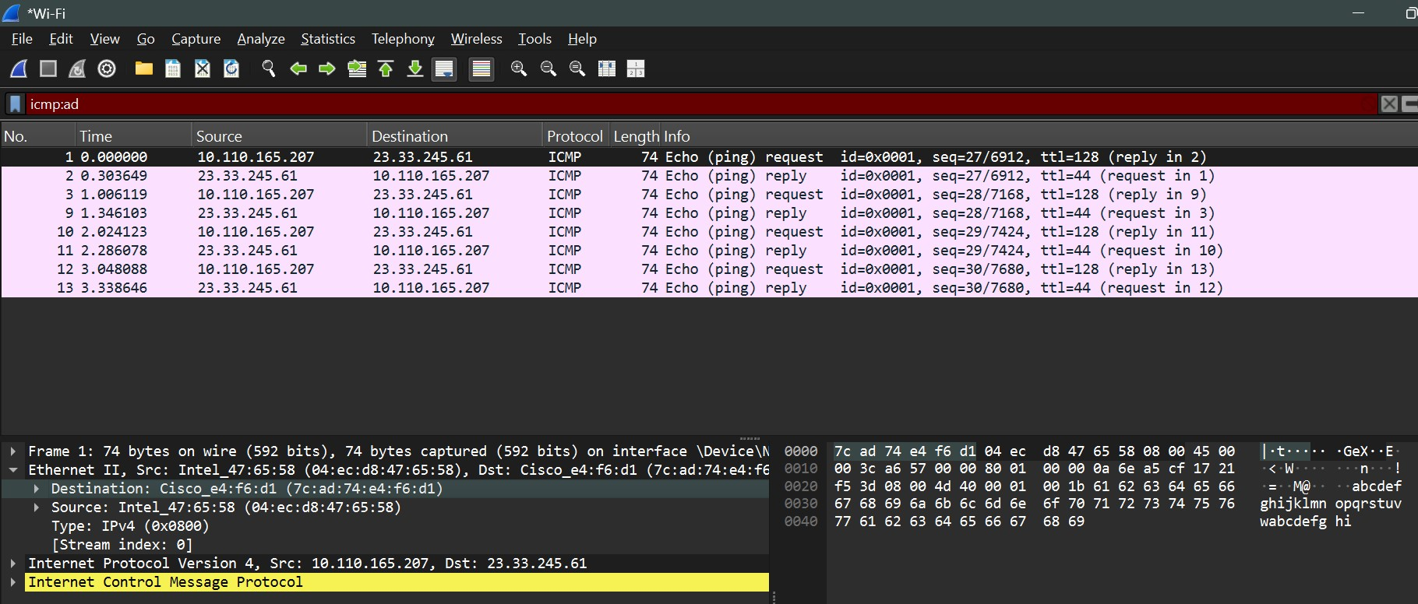

**Step 2: Examining and analyzing the data from the remote hosts**.

Review the captured data in Wireshark and examine the IP and MAC addresses of the three locations that you pinged.

List the destination IP and MAC addresses for all three locations in the space provided.

**IP address for** [**www.yahoo.com:**](http://www.yahoo.com/)

87.248.119.251

**MAC address for** [**www.yahoo.com:**](http://www.yahoo.com/)

7c:ad:74:e4:f6:d1

**IP address for** [**www.cisco.com:**](http://www.cisco.com/)

23.33.245.61

**MAC address for** [**www.cisco.com:**](http://www.cisco.com/)

7c:ad:74:e4:f6:d1

**IP address for** [**www.google.com:**](http://www.google.com/)

172.217.19.228

**MAC address for** [**www.google.com:**](http://www.google.com/)

7c:ad:74:e4:f6:d1

**What is significant about this information?**

The significant point is that while we can see the destination IP addresses for the remote websites, But the MAC addresses of all of them are same which means Wireshark does not show the actual MAC addresses of those remote servers.

**How does this information differ from the local ping information you received in Part 1?**

In Part 1, Wireshark showed the actual MAC address of the destination PC on your local network.

**Why does Wireshark show the actual MAC address of the local hosts, but not the actual MAC address for the remote hosts?**

Wireshark captures traffic on local network interface, where MAC addresses (Layer 2) are relevant. For remote hosts, traffic goes through local routers, so Wireshark only captures the MAC addresses involved in that immediate local communication, not the remote host's actual MAC address.

**CSE 303L: Data Communication and Computer Networks**

|  |  |  |  |  |
| --- | --- | --- | --- | --- |
| **Demonstration of Concepts** | **Poor (Does not meet expectation**  **(1))**    The student failed to demonstrate a clear understanding of the assignment concepts | **Fair (Meet**  **Expectation**  **(2-3))**    The student demonstrated a clear understanding of some of the assignment concepts | **Good (Exceeds**  **Expectation (4-5)**    The student demonstrated a clear understanding of the assignment concepts | **Score**      **30%** |
| **Accuracy** | The student misconfigured enough network settings that the lab computer couldn't function properly on the network | The student configured enough network settings that the lab computer partially functioned on the network | The student configured the network settings that the lab computer fully functioned on the network | **30%** |
| **Following**  **Directions** | The student clearly failed to follow the verbal and written instructions to successfully complete the lab | The student failed to follow the some of the verbal and written instructions to successfully complete all requirements of the lab | The student followed the verbal and written instructions to successfully complete requirements of the lab | **20%** |
| **Time Utilization** | The student failed to complete even part of the lab in the allotted amount of time | The student failed to complete the entire lab in the allotted amount of time | The student completed the lab in its entirety in the al | **20%** |